**Create the App Catalog site collection**

The first step is to create the App Catalog site collection if it hasn't already been created.

1. Go to SharePoint Admin Center
   1. <https://[tenant]-admin.sharepoint.com>
2. SharePoint Framework solutions are deployed to an app catalog when they are ready for distribution
3. Under **Apps**, select **Open**

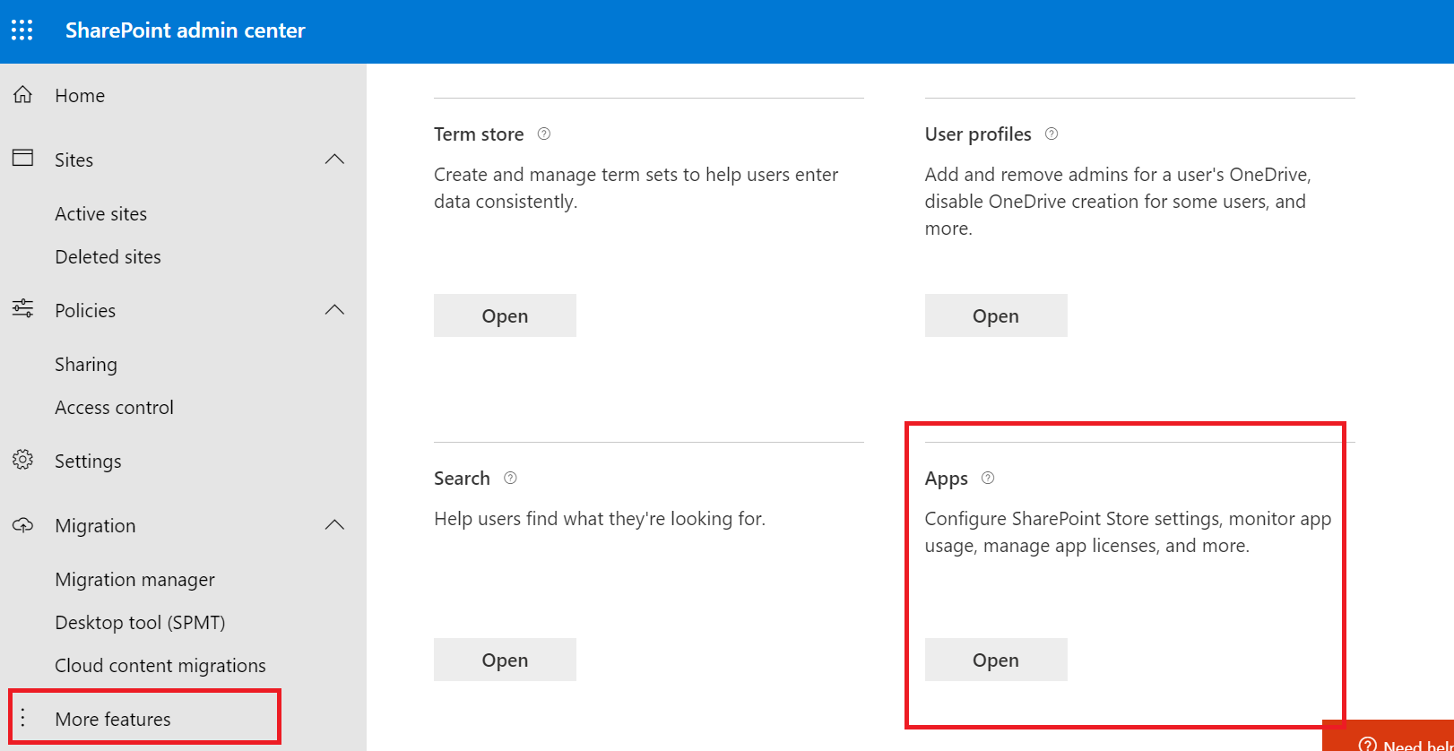

1. Select **App Catalog**.
2. If the **App Catalog** site doesn't open, select **Create a new app catalog site**, and then select OK.
3. App catalog site dialog with Create a new app catalog site selected.

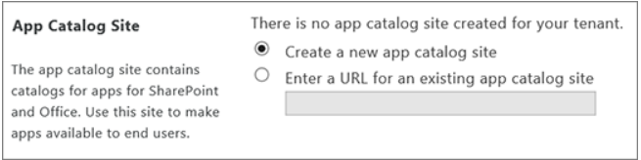

1. On the **Create App Catalog** Site Collection page, enter the required info, and then select **OK**

